Social-Emotional Development in Preschoolers
Kate Zinsser • Mar 23, 2015
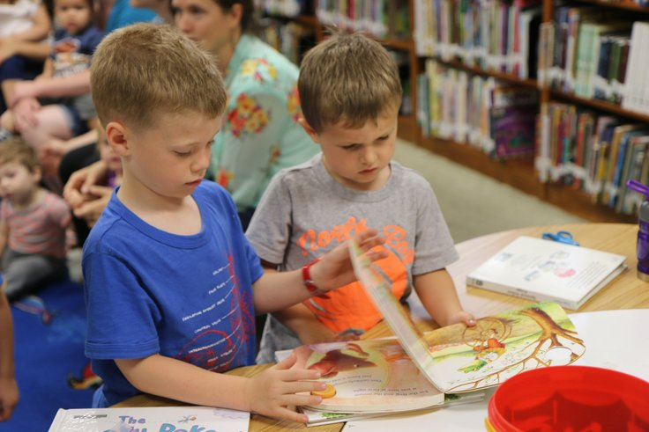
In their preschool year(s), young children are hard at work getting ready for elementary school — learning their letters and shapes, and refining their gross and fine motor skills — but these aren’t the only abilities they’ll need to succeed in school.
To prepare for kindergarten, children also begin to develop a set of behavioral and emotional skills called social and emotional competencies that include being socially and emotionally aware, being emotionally and behaviorally regulated, and making responsible decisions. Preschool-aged children are making early strides in these areas, but the process of learning these competencies, called social and emotional learning (SEL), is lifelong.

Being Socially and Emotionally Aware
Social and emotional awareness describes the ability to identify your own and others’ emotions, as well as to empathize with someone — even when you feel differently. Key to this awareness is a general knowledge of emotions, which evolves quickly in early childhood. Most preschoolers can express, name, and recognize all the basic emotions — happiness, sadness, anger, fear, and surprise — and talk about them in ways that relate to their own experiences.
- What makes me feel happy? (“Making a mess with my blocks.”)
- What makes my mommy (or daddy) angry? (“When I wake her (or him) up too early ... ”)
- How do I know my mommy is angry? (“She yells.”)
- What would my daddy do if I was afraid at bedtime? (“He would get a night light.”)
Young children are also developing the building blocks of more sophisticated emotion-related knowledge, including equivocal emotions (some people love oatmeal, while others find it disgusting); social emotions (empathy, shame, guilt, and contempt); and blended emotions (e.g., feeling both sadness and anger simultaneously). They’re hard at work using facial cues to recognize the emotions of others, though they may often mislabel them. For example, a preschooler might misinterpret a friend’s crying as sadness, instead of fear or frustration.

Being Emotionally and Behaviorally Regulated
Emotional and behavioral regulation describes the ability to manage one's emotions and behaviors across different situations in order to meet short- and long-term goals. Young children are working hard to control their experience of emotion and to manage their behaviors in order to comply with social norms.
Preschoolers are constantly developing and fine-tuning their emotional “thermostats” — figuring out which emotions to regulate, when, and why. They are also learning which outward expressions of emotion help them achieve the desired result of “feeling better.” That is, a child at this age may react to frustration by throwing or hitting, or react to boredom by being overly silly or disruptive.
Strong emotions can be overwhelming for young children — just as they are for adults! A preschooler who is competent at emotional regulation, though, may try taking three deep breaths to calm down when her block tower gets destroyed by a younger sibling.
Children this age also learn to amplify their experience or expression of a negative emotion in order to get their demands met (think of a temper tantrum), or of a positive emotion (saying thank you for a gift they don’t particularly like) in order to maintain a friendship.
Similarly, preschool-aged children are beginning to learn to inhibit inappropriate behaviors — refraining from taking a friend’s cookie even though they really want it, or waiting patiently for their turn at the water fountain. They are also learning that different contexts have different behavioral norms (e.g., you can shout in the playground, but you need to be quiet in the library).

Making Socially-Responsible Decisions
Responsible decision-making describes the ability to consider social norms and the consequences of one’s actions when making decisions about how to behave in social interactions.
As young children become more socially and emotionally aware, they learn that others may feel differently than they do and begin to consider others' feelings when deciding how to act. This process of making appropriate choices is critical to successfully building and maintaining friendships and to positively participating in their classroom communities.
Young children are learning to use a host of social and emotional information to make constructive and responsible choices about their behavior. For example, a preschooler may be tempted to knock over a block tower, but she is learning to consider the feelings of the other children who helped build it, the safety of those around the tower, and the classroom rules about playing with blocks.
Similarly, the child whose tower is knocked over is learning to use social and emotional clues to consider the destroyer’s motivation (did she do that on purpose, or was it an accident?) before responding. Making socially responsible decisions to cooperate or share helps to set children up for success, both socially and academically.

A Final Observation
Over time, children who are more socially and emotionally skilled have greater success making and keeping friends, find school to be more enjoyable, and tend to receive higher grades later in elementary school — above and beyond the contributions that intelligence, socioeconomic status, and family structure make to school performance.

